Assignment lab1 Report

11912013 易翔
Q1. Done through in class check.
Q2. 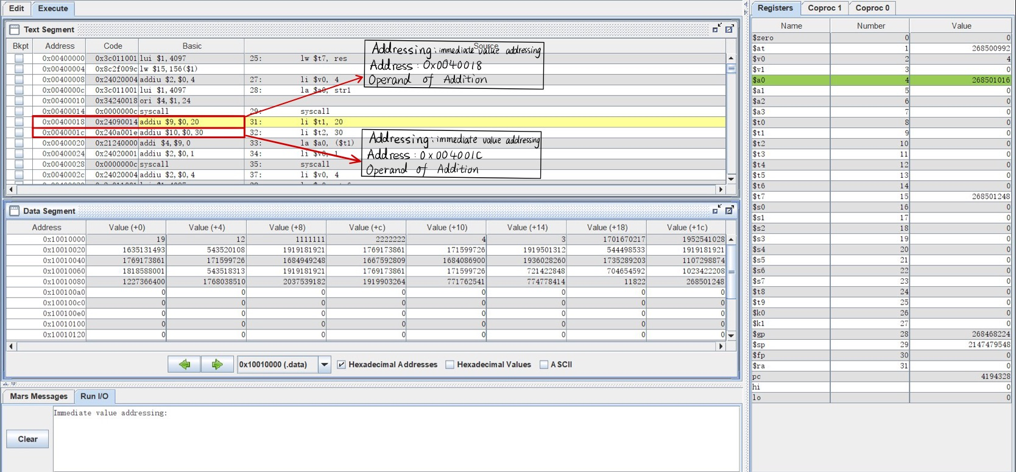
Fig1. screen shot of data segment before running addition
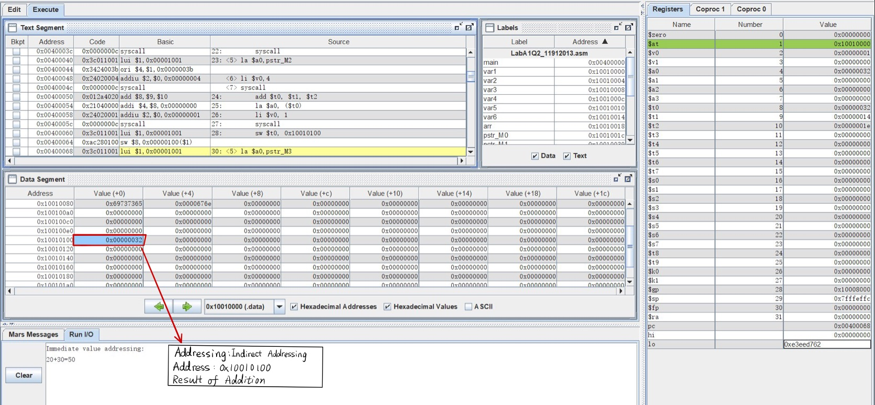
Fig2. screen shot of data segment after running addition
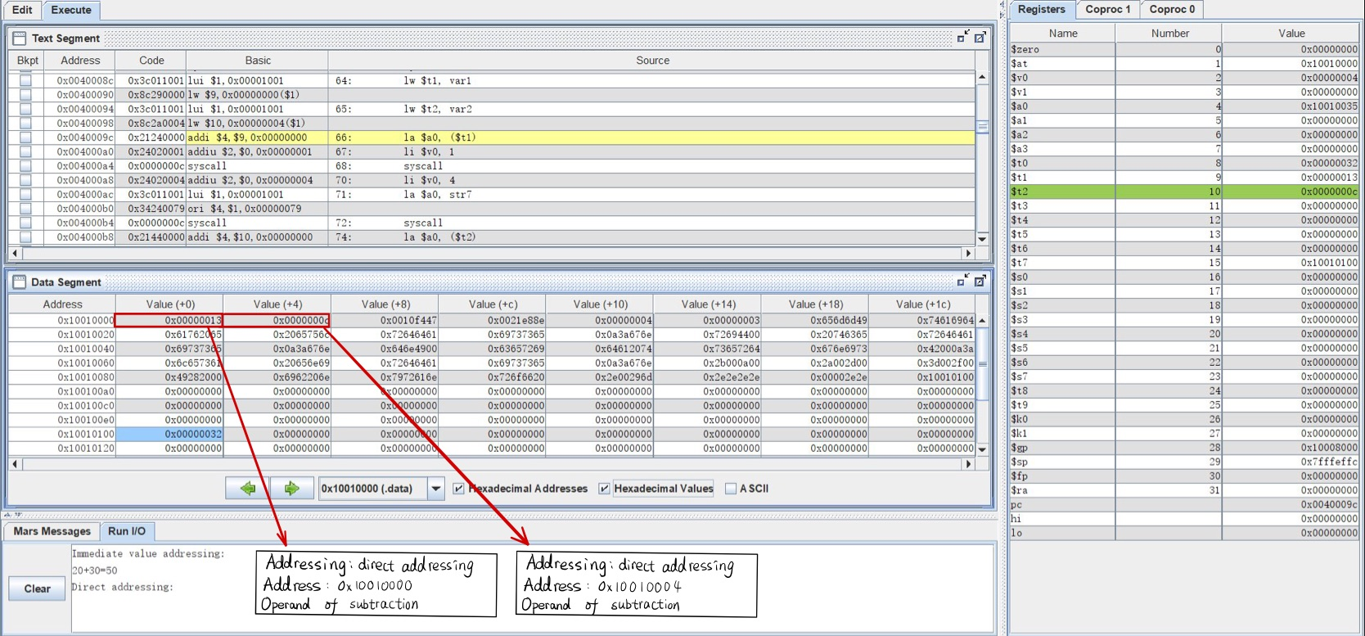
Fig3. screen shot of data segment before running subtraction
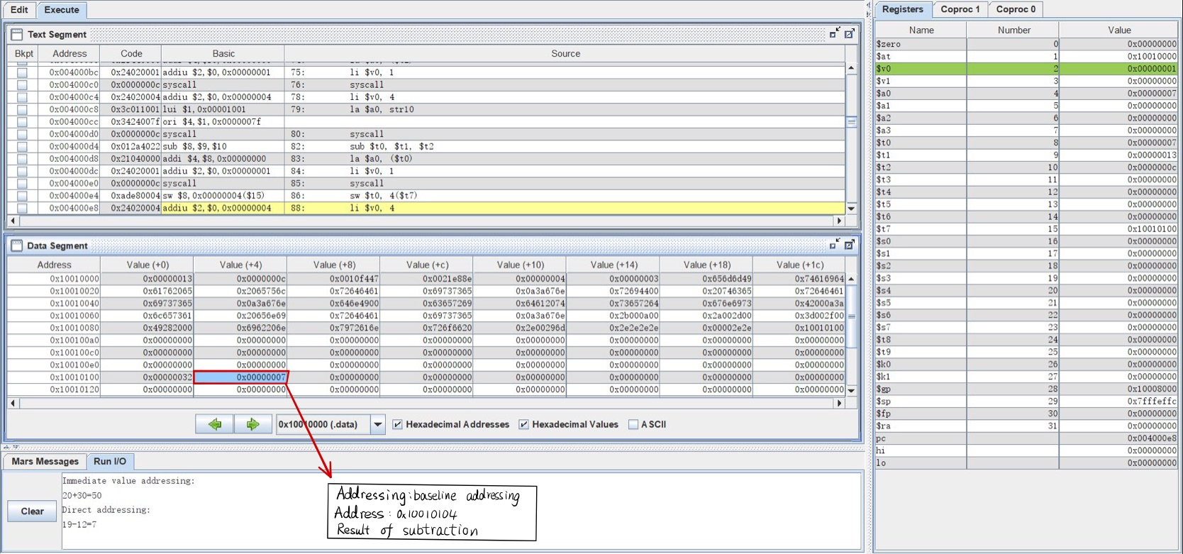
Fig4. screen shot of data segment after running subtraction
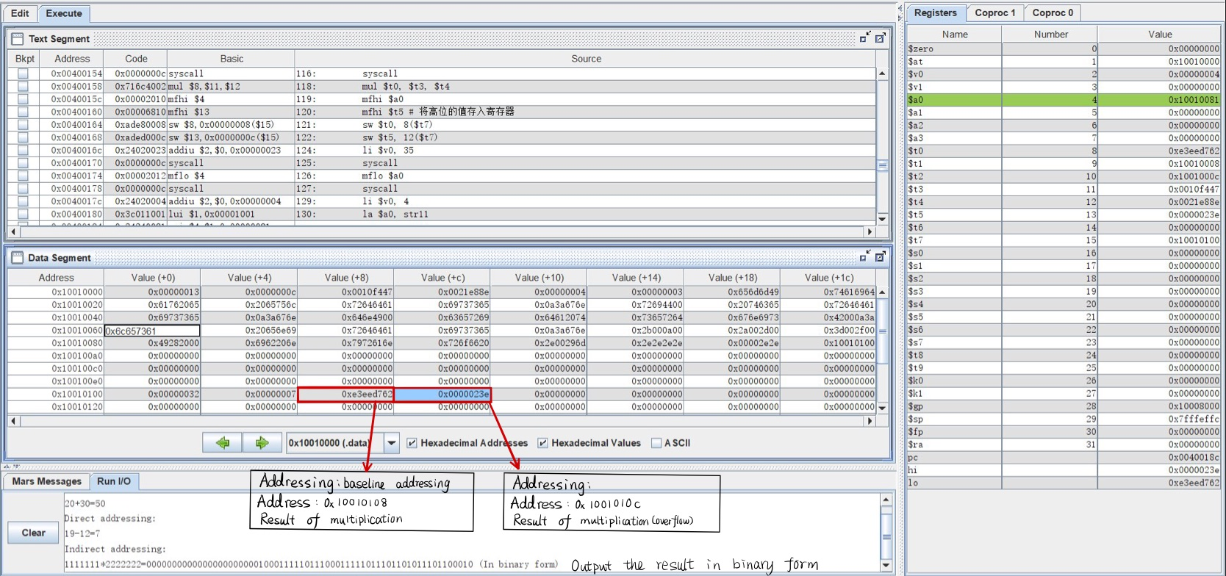
Fig5. screen shot of data segment before running multiplication
Fig6. screen shot of data segment after running multiplication
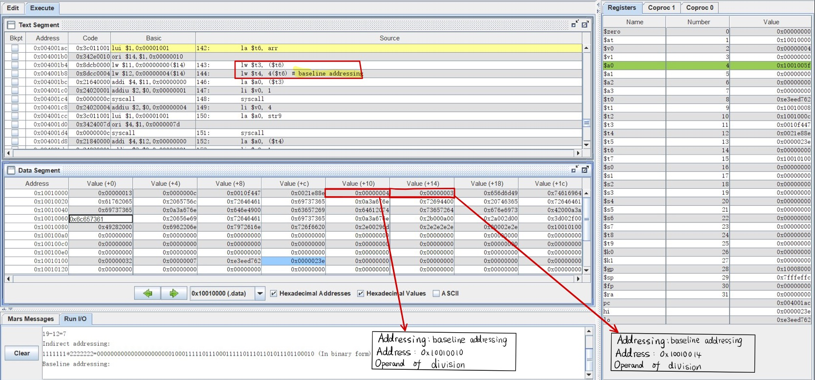
Fig7. screen shot of data segment before running division
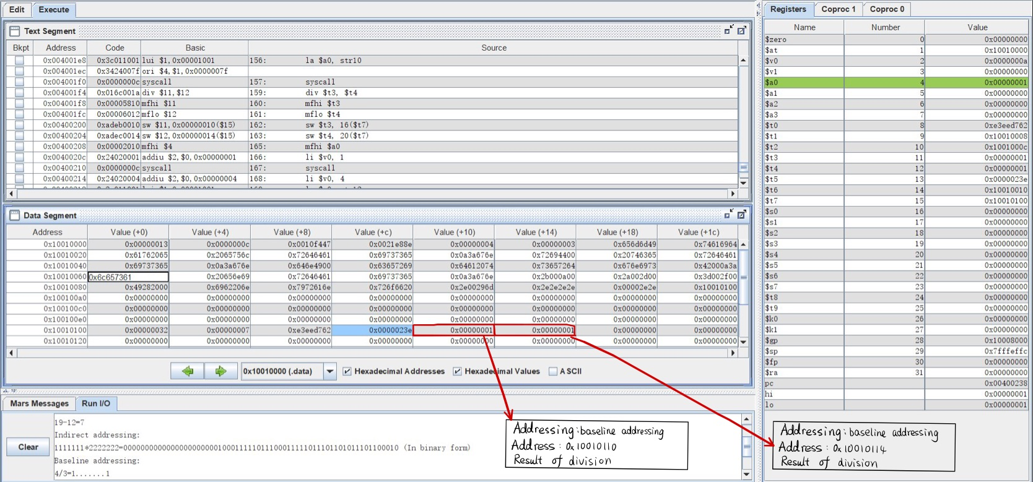
Fig8. screen shot of data segment after running division

